

SCHOOL OF MECHANICAL & MANUFACTURING ENGINERRING

NUST

Department of Mechanical Engineering

CS-114 – Fundamentals of Programming

LAB MANUAL #08

**Course Instructor**: Dr Khawaja Fahd Iqbal

**Lab Instructor**: Muhammad Affan

**Student Name**: Muhammad Usman Abdullah

**Section**: B

**CMS ID**: 461513

**DATE**: 30-November-2023

LAB #08 (LAB TASK)

TASK 1:

#include <iostream>

using namespace std;

int main(){

int size, sum=0,average;

cout<<"Enter the size of array: "<<endl;

cin>>size;

int arr[size];

cout<<"Enter the elements of array: "<<endl;

for(int i=0;i<size;i++){

cin>>arr[i];

}

for(int i=0;i<size;i++){

sum+=arr[i];

}

average=sum/size;

cout<<"The average is: "<<average;

return 0;

}

OUTPUT:

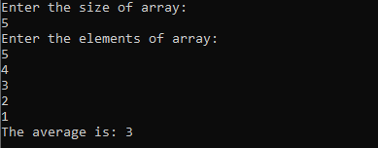

TASK 2:

using namespace std;

int main(){

int arr[5],b;

cout<<"Enter the elements of array: "<<endl;

for(int i=0;i<5;i++){

cin>>arr[i];

}

for(int i=0;i<4;i++){

for(int j=0;j<4;j++){

if(arr[j]>arr[j+1]){

b=arr[j];

arr[j]=arr[j+1];

arr[j+1]=b;

}

}

}

cout<<"The Sorted Array Is: "<<endl;

for(int i=0;i<5;i++){

cout<<arr[i]<<" ";

}

return 0;

}

OUTPUT:

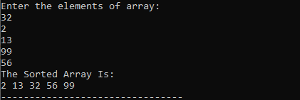

TASK 3:

#include <iostream>

using namespace std;

int main() {

int arr[5];

cout<<"Enter the elements of the array: "<<endl;

for(int i=0;i<5;i++){

cin>>arr[i];

}

int min, temp;

for(int i = 0; i < 5; i++) {

min = i;

for(int j = i + 1; j < 5; j++) {

if(arr[j] < arr[min]) {

min = j;

}

}

if(min != i) {

temp = arr[i];

arr[i] = arr[min];

arr[min] = temp;

}

}

for(int i = 0; i < 5; i++) {

cout << arr[i] << " ";

}

return 0;

}

OUTPUT:

